
Name: Aleke James
ID: 669116
Task: Class exercise
Course code: APT3040
Course name: Object oriented

Q1. Write a java program to draw a diamond chip
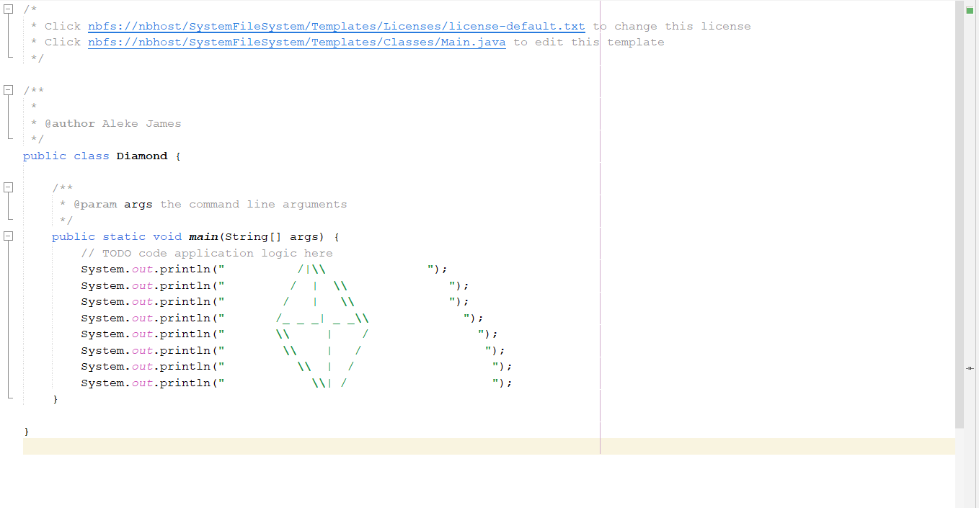

Q2. Write a java program to compute the volume of a cylinder
V$=πr^{2}$h
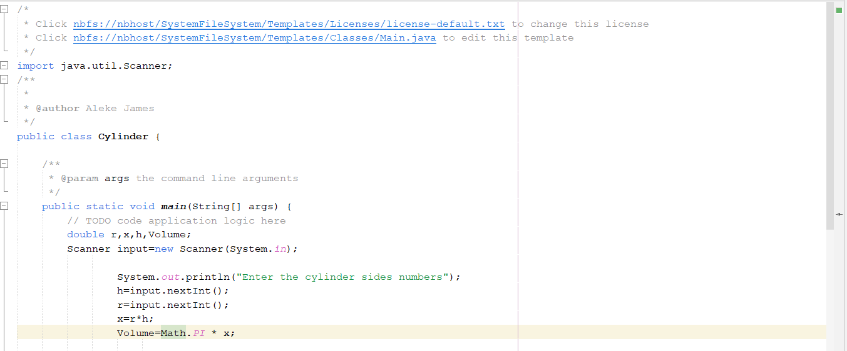

Q3. Write a java to compute area of a circle ($A=πr^{2})$
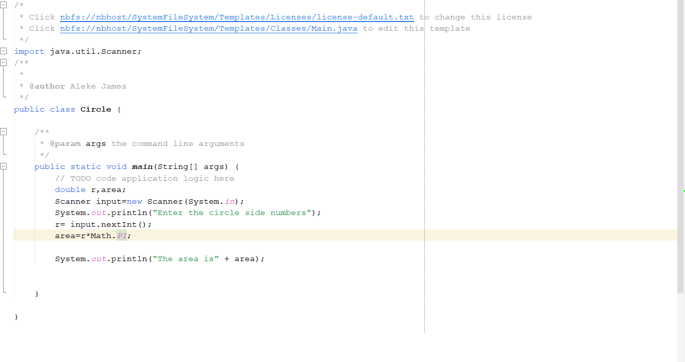

Q4. Write a java program to compute (X^n)
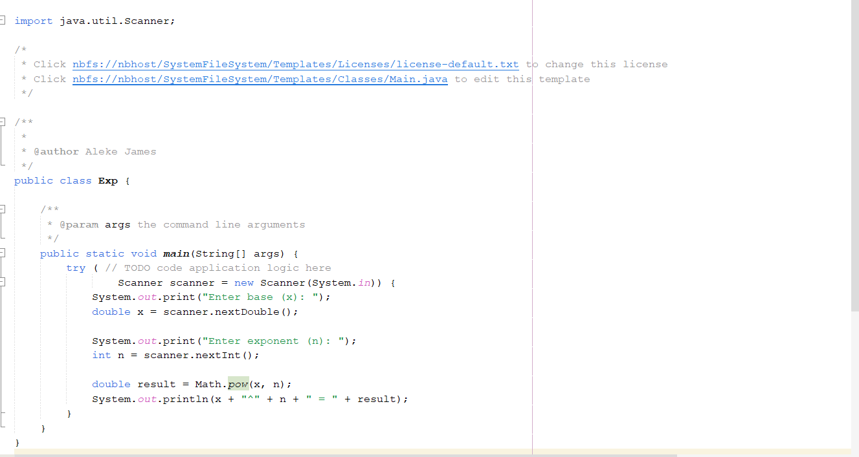
Q5. Write a java program for computing area of irregular triangle
$$A=\frac{\sqrt{s(s-a(s-b)(s-c)}}{1}$$
A,b,c are sides of the triangle and s=1/2 perimeter

